#### Filling missing constituent data

The Swan Canning catchment model produced flow, total nitrogen and total phosphorus as outputs. However, there were other variables that needed to be added to the estuary inflow files, which were not simulated in the catchment model, such as dissolved oxygen and salinity (Table 1). These variables were taken from observed data. For areas where there was no observed data, the values were taken from sites that were adjacent and had similar land use properties (Figure 4). For example, the observed salinity at the Bayswater gauge was used for all downstream inflows to the estuary.

Further, the catchment model was not designed to resolve chemical speciation, between, for example, nitrate, ammonium and organic nitrogen, which are variables required for the SCERM boundary inputs. Therefore, the TN and TP from the catchment model outputs were split into their chemical species by using the observed daily data of ratios found at those sites. For example, if ammonium was 40% of observed total nitrogen (TNobs) on 1 January at the Bayswater gauge, then all simulated TN inflows to the estuary in the downstream areas were multiplied by 40%, to produce ammonium inputs on 1 January.

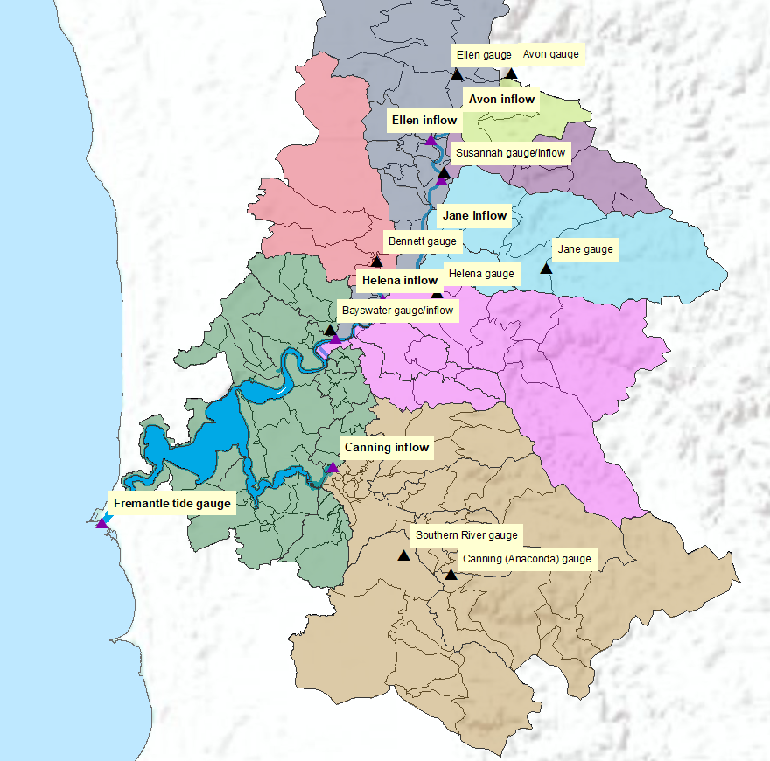

Figure Areas that used the same chemical inflow ratios are shown with the same colour. The Canning gauges have flow only and the water quality data is taken at Kent Street Weir.

Table 1 Variables input into SCERM from either observed daily data (obs), the catchment model (catch) or as a function of catchment model inputs and observed data.

|  |  |  |
| --- | --- | --- |
| **Required Variable** | **Unit** | **Conversion** |
| Flowcatch | m3 s-1 | Input from catchment model |
| Salinity | PSU | Observed data |
| Temperature | °C | Observed data |
| TSS | mg L-1 | Observed data |
| Oxygen | mmol m-3 | Observed data |
| Silica | mmol m-3 | Observed data |
| Particulate organic P (POP) | mmol m-3 | Observed data |
| Total Chl-*a* (TCHLA) | ug L-1 | Observed data |
| NH4+ | mmol m-3 | TNcatch × (NH4+obs / TNobs) |
| NO3- | mmol m-3 | TNcatch × (NO3-obs / TNobs) |
| Dissolved organic N (DON) | mmol m-3 | TNcatch × (DONobs / TNobs) |
| Particulate organic N (PON) | mmol m-3 | TNcatch × (PONobs / TNobs) |
| TNcatch | mmol m-3 | Input from catchment model |
| PO43- | mmol m-3 | TPcatch × (PO43-obs / TPobs) |
| Organic P (OP) | mmol m-3 | TPcatch - (PO43-obs) – (PO43-obs * 0.1) |
| TPcatch | mmol m-3 | Input from catchment model |
| Dissolved organic C (DOC) | mmol m-3 | Observed data |
| Particulate organic C (POC) | mmol m-3 | Observed data |

Appendix

|  |  |  |
| --- | --- | --- |
| **Required TFV Variable** | **Processed Catchment Variable** | **Conversion Factor** |
| Flow | Flowcatch | 1 |
| Sal | Salinity | 1 |
| Temp | Temperature | 1 |
| TRACE_1 | zeroes | 1 |
| AGE | zeroes | 1 |
| SS1 | TSS | 0.3 |
| SS2 | TSS | 0.7 |
| Oxy | Oxygen | 1 |
| Sil | Silica | 1 |
| NH4 | NH4+ | 1 |
| NO3 | NO3- | 1 |
| PO4 | PO43- | 1 |
| FRP_ADS | PO43- | 0.1 |
| DOC | DOC | 0.1 |
| POC | POC | 0.5 |
| DON | DON | 0.3 |
| PON | PON | 1 |
| DOP | OP | 0.3 |
| POP | OP | 0.5 |
| DOCR | DOC | 0.9 |
| DONR | DON | 0.7 |
| DOPR | OP | 0.2 |
| CPOM | POC | 0.5 |
| GRN | TCHLA | 0.167 |
| BGA | TCHLA | 0.125 |
| CRYPT | TCHLA | 0.333 |
| DIATOM | TCHLA | 2.292 |
| DINO | TCHLA | 1.25 |
| DINO_IN | TCHLA | 0.00754717 |